**SCBI**

GAMM:  
[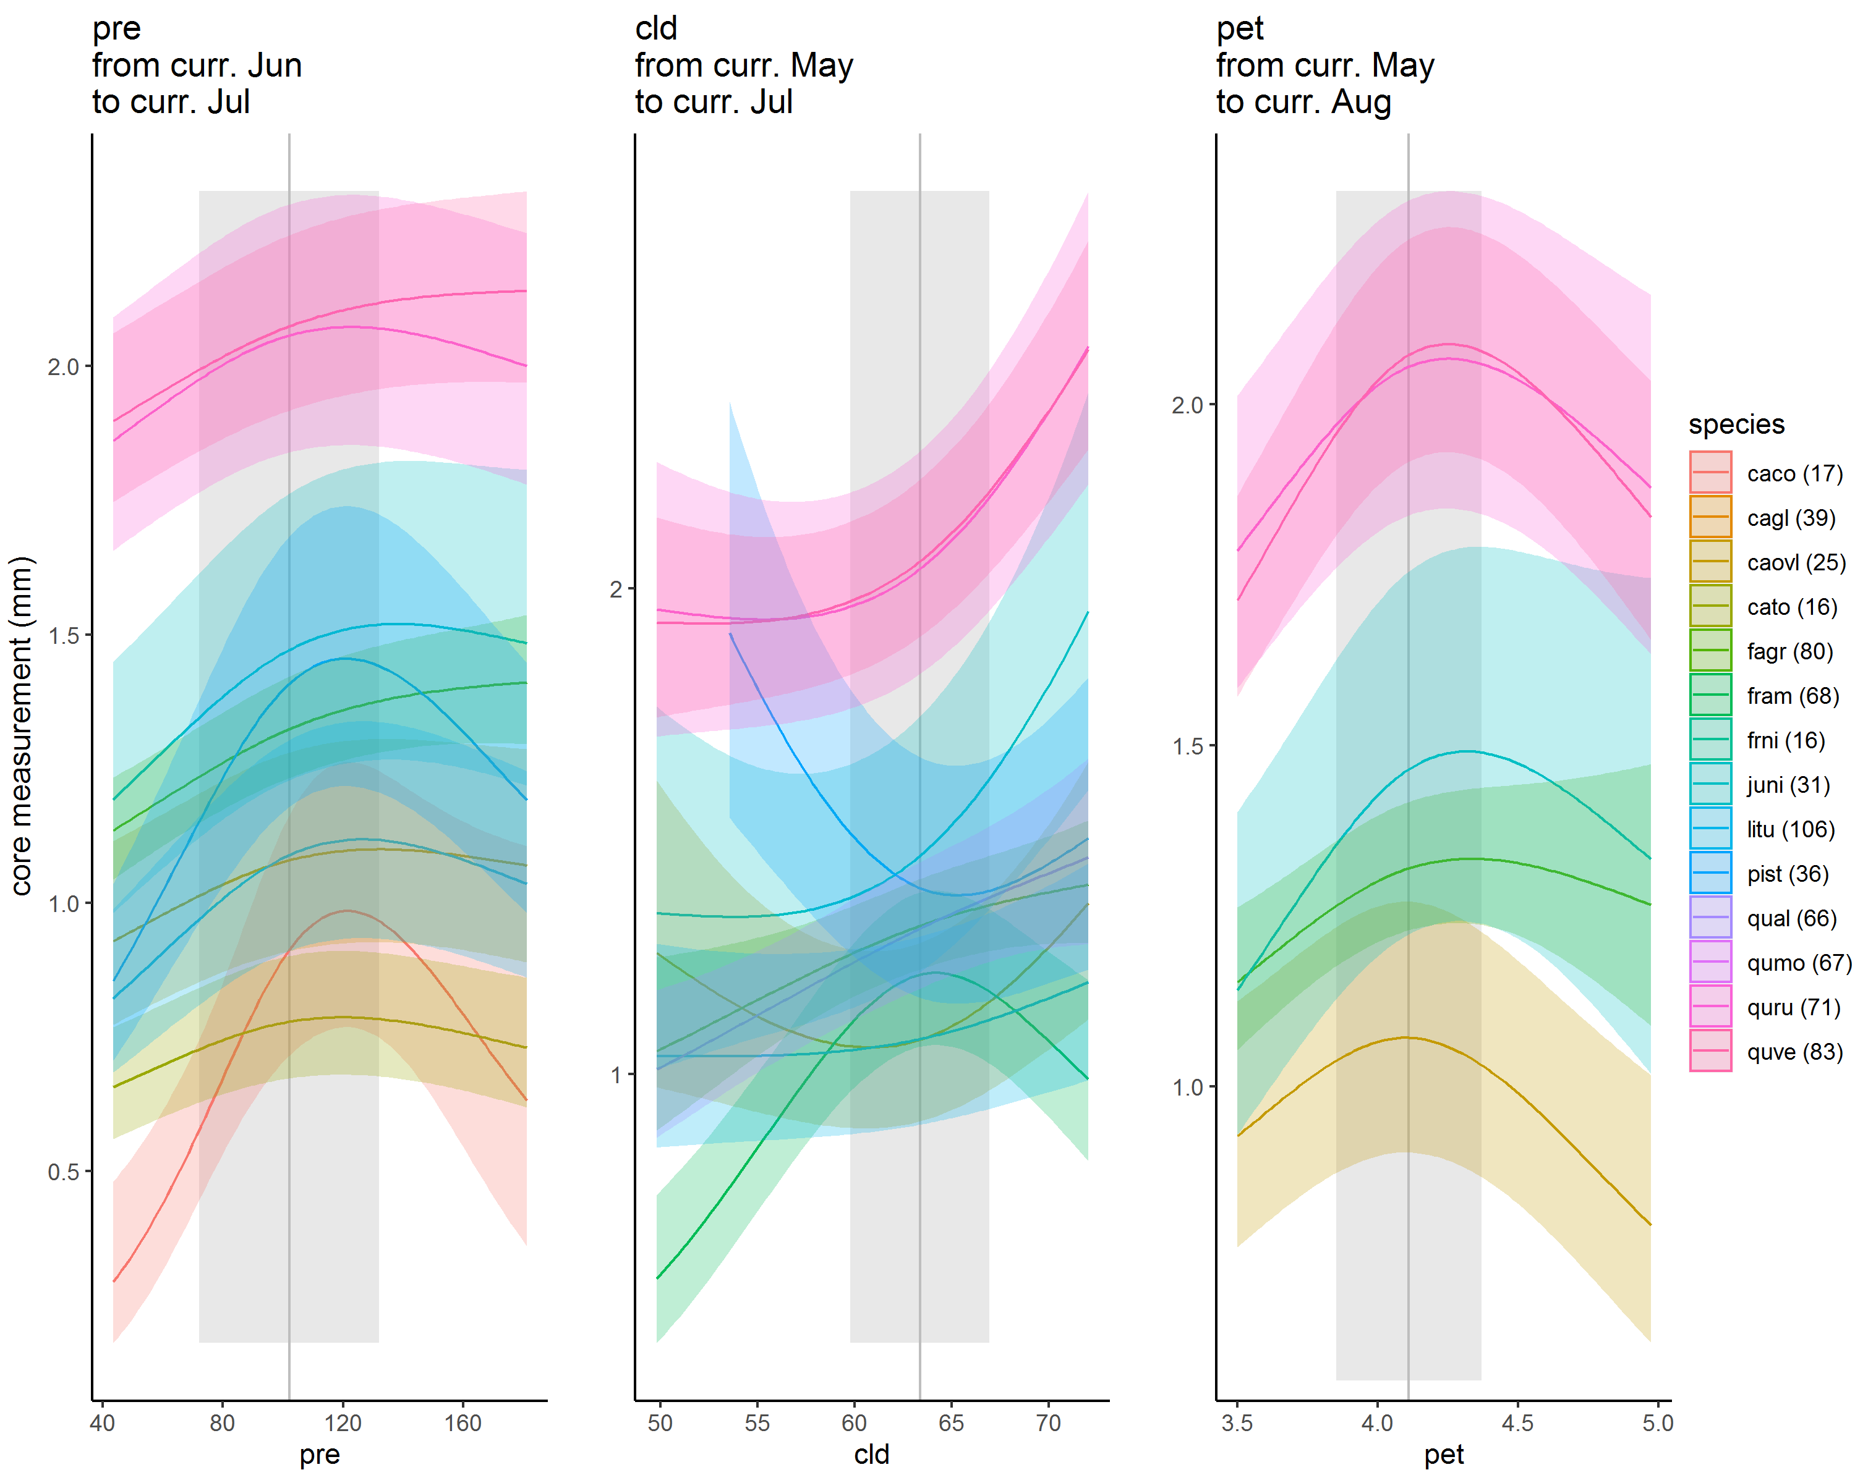](https://user-images.githubusercontent.com/6355854/82463563-fbddc180-9a8a-11ea-9d4b-d99414c41e48.png)

**June- July precip response** - *makes sense* - positive response in both climwin and latest GAMM, consistent with Helcoski.  
[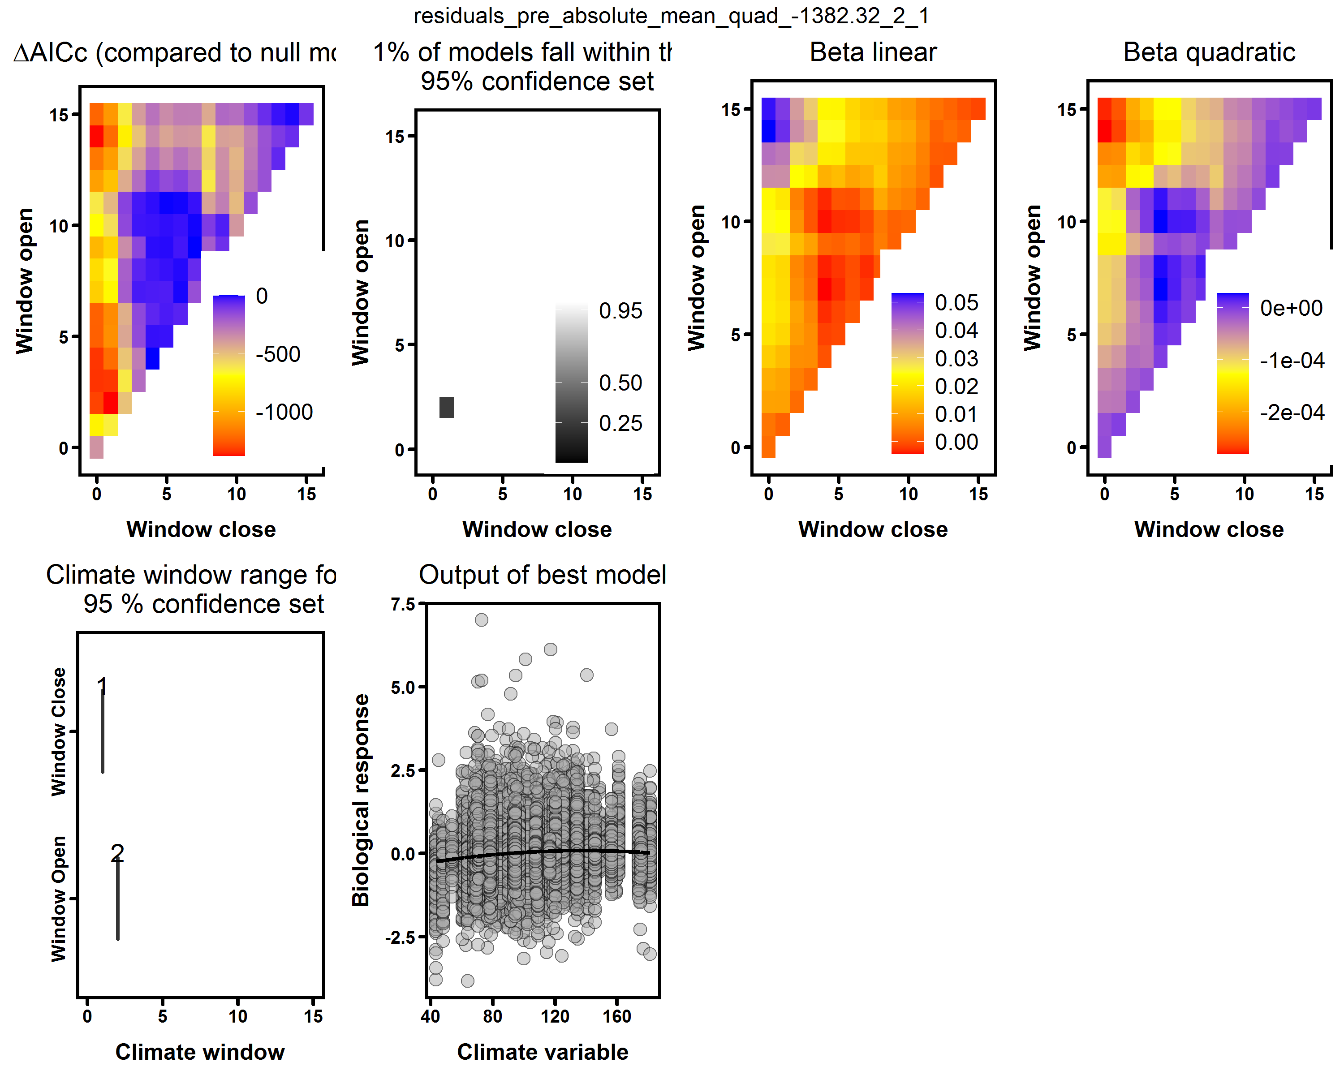](https://user-images.githubusercontent.com/6355854/82463845-5414c380-9a8b-11ea-8bbc-ffbe456cf946.png)

**May-July cloud response** - *makes sense* - positive response in both climwin and latest GAMM (for most species), consistent with Helcoski.  
[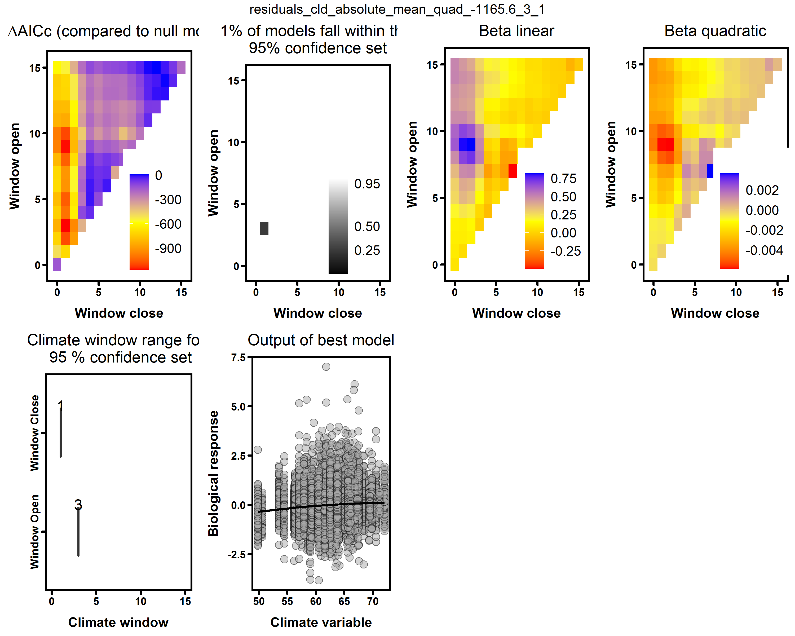](https://user-images.githubusercontent.com/6355854/82464036-950cd800-9a8b-11ea-820c-53aa36def5e0.png)

**May-Aug PET response** - *probably makes sense* -decline at high PET in both climwin and latest GAMM (for most species), consistent with Helcoski.  
[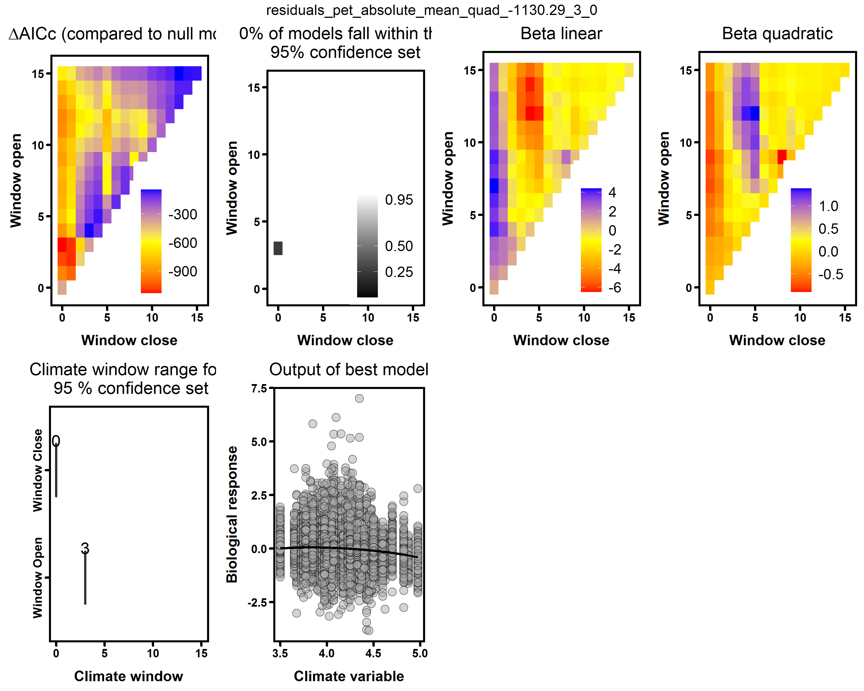](https://user-images.githubusercontent.com/6355854/82464197-cb4a5780-9a8b-11ea-86c5-efc1a4a1ea72.png)

*bottom line-- I think the SCBI responses all make sense.*